Y Axis Assembly

Vitamins
1 Belt GT2 x 6mm x 662mm  4 M3 cap screw x 16mm  8 M4 cap screw x 16mm  4 Nyloc nut M3  8 Nyloc nut M4  2 No2 pan wood screw x 13mm | 1 Smooth rod 8mm x 270mm  1 Smooth rod 8mm x 417mm  1 Microswitch  2 Washer M2.5 x 5.9mm x 0.5mm  4 Washer M3 x 7mm x 0.5mm  8 Washer M4 x 9mm x 0.8mm

Printed parts
3 y_bar_clamp.stl  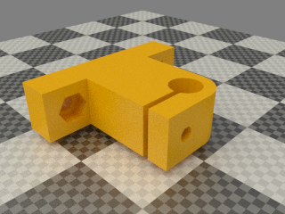 | 1 y_bar_clamp_switch.stl  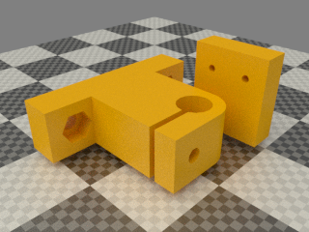

Sub-assemblies
1 print_bed_assembly  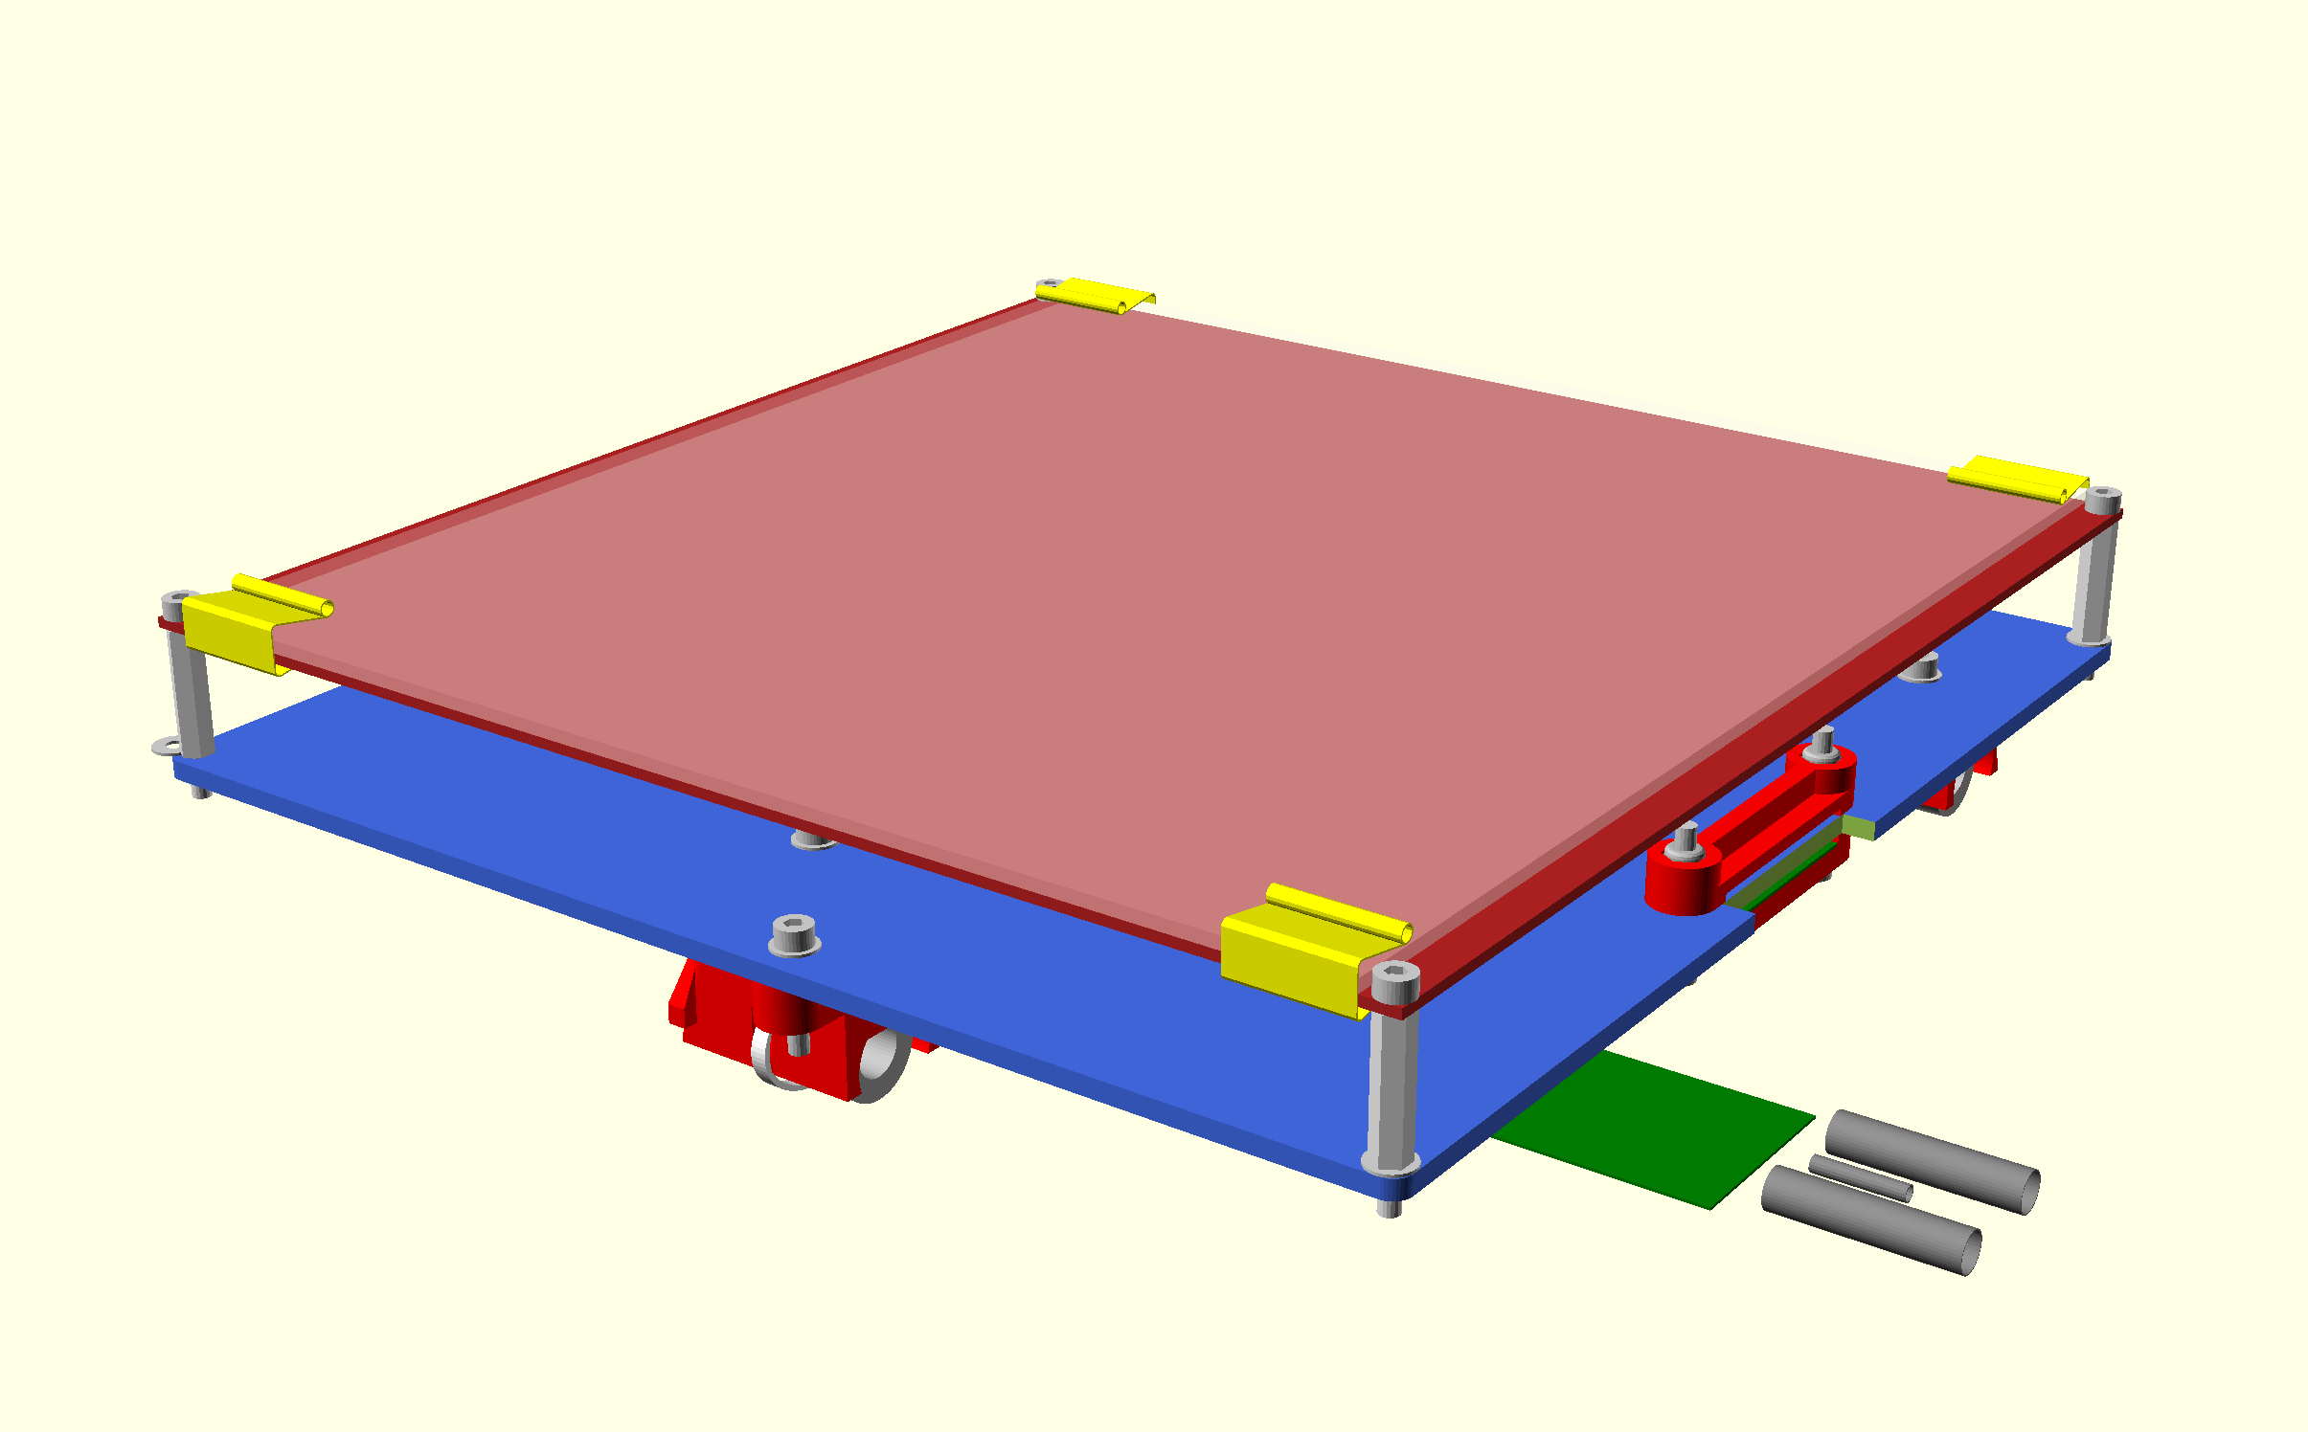 | 1 y_idler_assembly  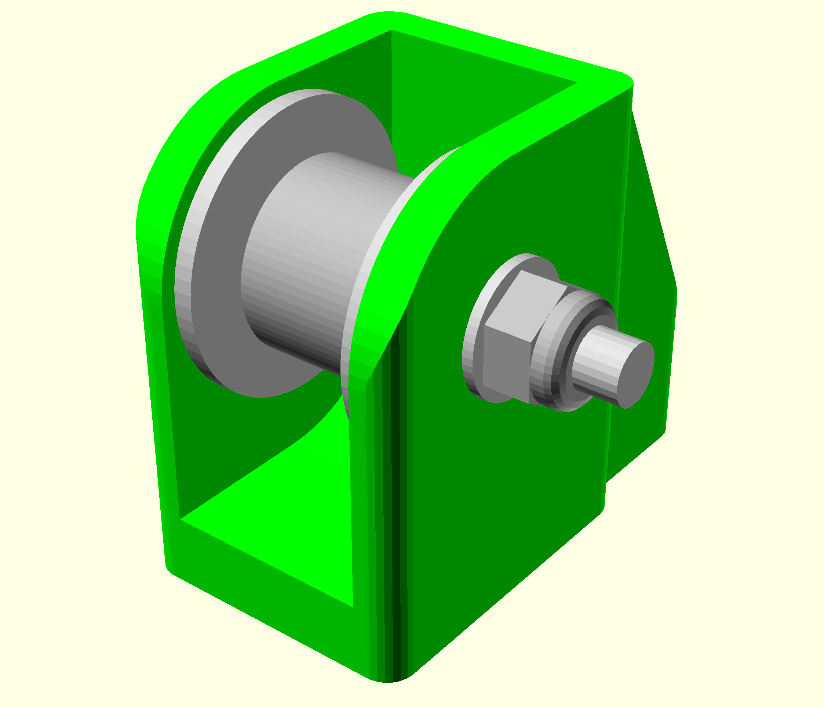 | 1 y_motor_assembly  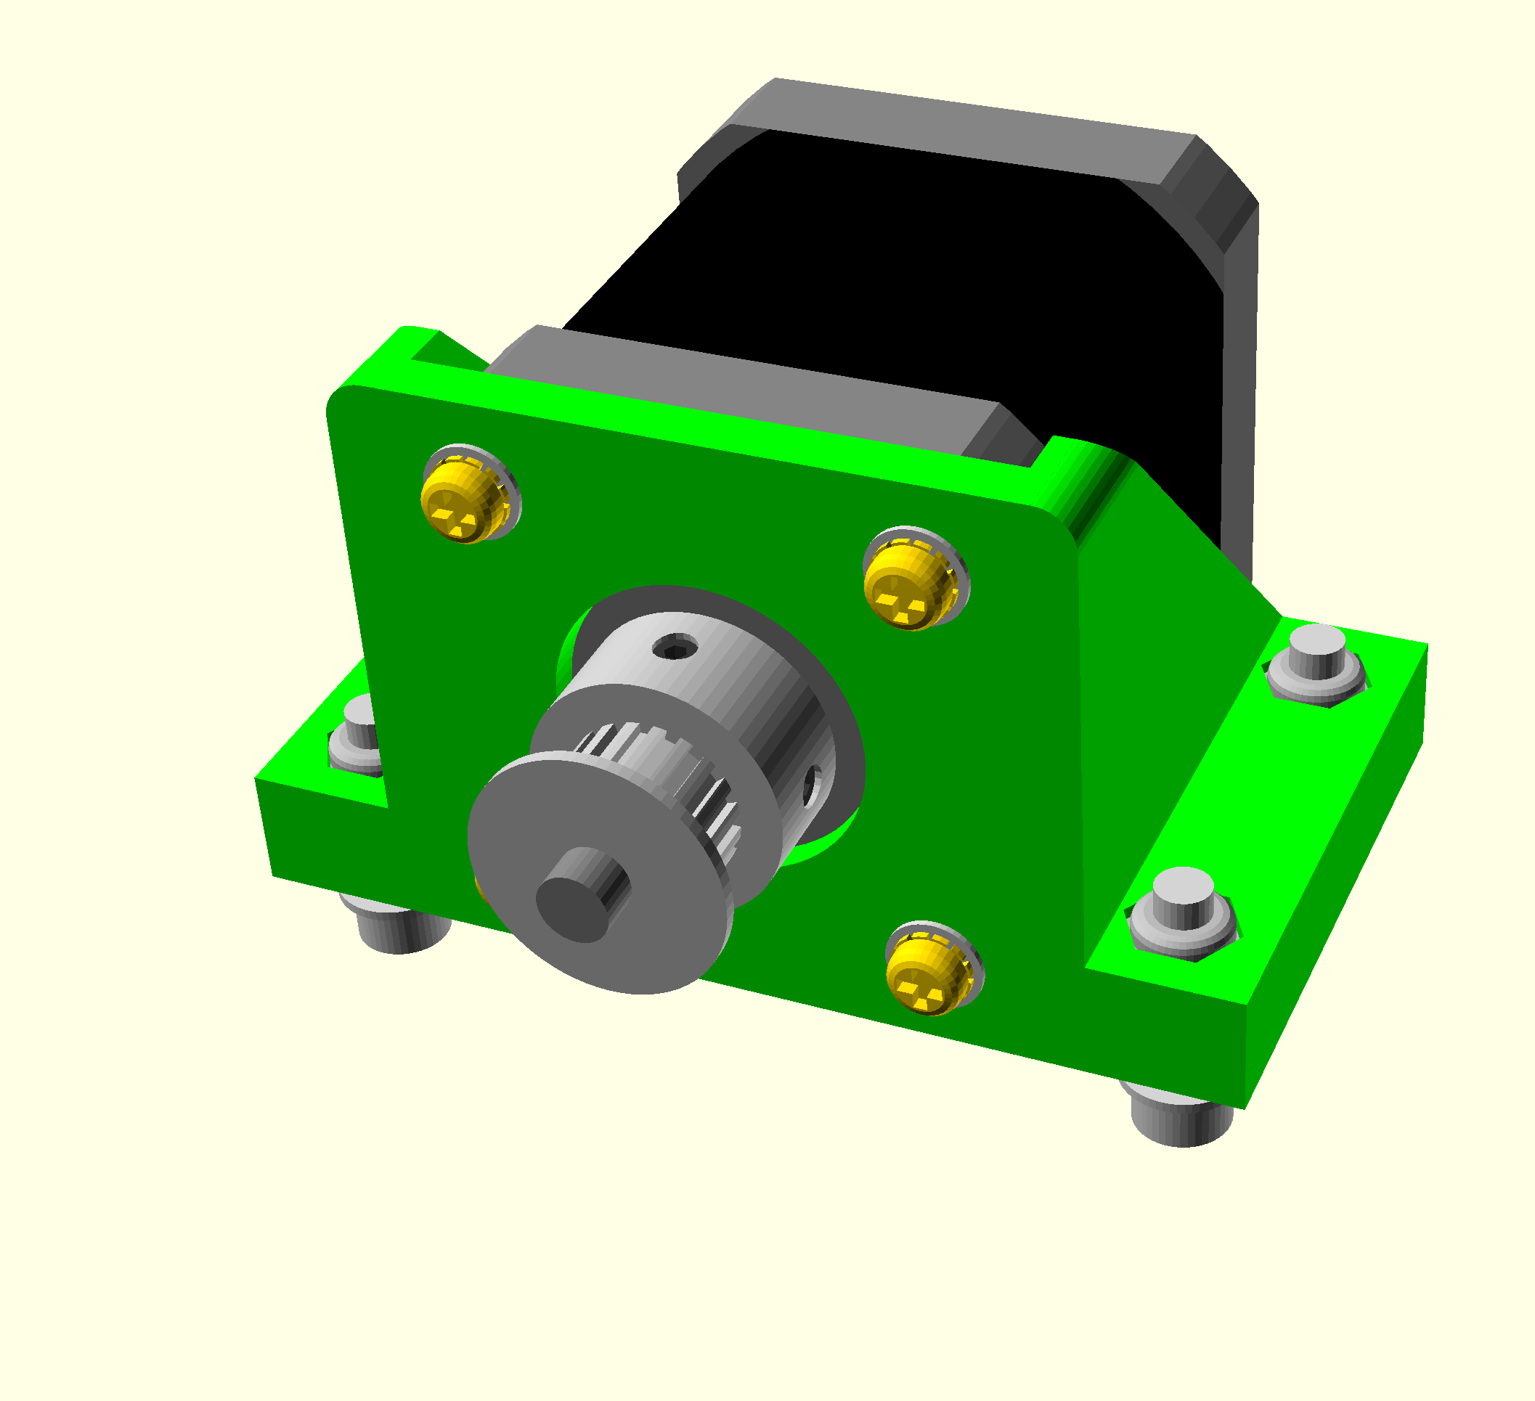

Assembly
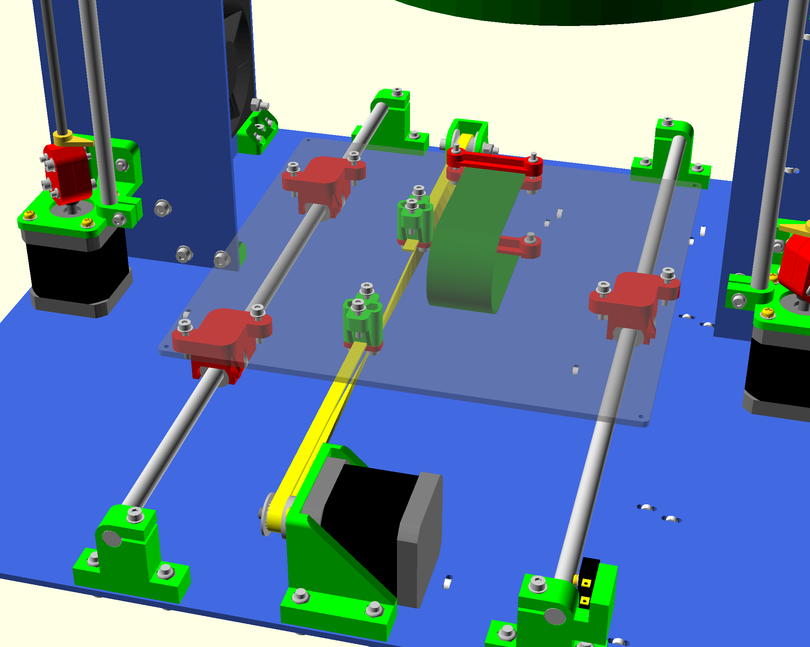
- Drill the 2 small holes in the switch bar clamp to 2.5mm
- tap the holes to 3mm
- Insert the captive nyloc M3 nuts and M3 x 16mm cap screws in each of the Y bar clamps.
- Loosely fit the two left hand Y bar clamps to the base. Orientate them so the rod is towards the outside of the machine.
- Twist together two green wires about 750mm long (trimmed from the X motor) and solder them to the outer two pins of the microswitch. Reem out the holes in the microswitch and attach it to the barclamp with M3 screws with M3 screws BUT NO wshers as it would prevent the smooth rod from going in the bar clamp. Remember the button towards the top and facing the back of the machine.
- Fit the right hand Y bar clamps to the base but leave the screws loose.
- Thread the limit switch wires through the zip ties and through mouse hole in the right stay.
- Also thread the Y motor wires through the zip ties in the base and then screw the Y motor bracket in place. Run the wires in the cable ties and holes parallel to the limit switch wires.
- Clamp the Y belt in the front belt anchor with the teeth facing away from the carriage. The end of the belt should project enough to have five complete teeth showing.
- Put a half twist in the belt and then thread it through the Y idler assembly with the smooth side against the bearings and then clamp it in the rear clamp with the teeth facing the carriage. Again leave five complete teeth projecting from the anchor.
- Slide the Y bars through the bar clamps and the carriage bearings. Tighten the clamps to grip the bars lightly but do not over-tighten them. Slide the carriage up and down to align the right hand bearing and bar clamps. Tighten the bearing first and then move it to each end and tighten the clamps.
- Put the belt over the motor pulley and fasten the idler assembly to the base with enough tension on the belt to play a low note when plucked. Ensure the belt runs in the middle of the idler without touching the washers each side by adjusting the angle of the idler.
- Attach the wires from the bed so that it forms a loop. The middle of the loops points towards the Y motor.
- The wires turn right and go through the cable ties and under the mouse holes in the right hand stay. The heater wires go through the rear tie and the larger hole.

